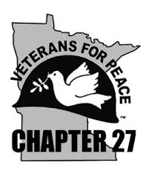
Veterans For Peace (VFP) is an international organization comprised of military veterans and allies. VFP Chapter 27, Twin Cities, is one of 150 chapters across the U.S. and abroad dedicated to building a culture of peace and justice, exposing the true costs of war, and healing the wounds of war.
Please Click here to donate.
Our mission includes programs and actions to:
- Seek justice for veterans and victims of war.
- Abolish war as an instrument of national policy.
- Restrain our government from intervening, overtly and covertly, in the internal affairs of other nations.
- End the arms race and eliminate nuclear weapons.
Our chapter has organized or supported a number of actions and initiatives in 2018. They include:
- A walk with Korean-American photographer Kyong Juhn on her 20-day, 300 mile Walk for Hope and Peace from Rochester to Bemidji Minnesota in May.
- The annual Memorial Day ceremony at the Vietnam Veterans Memorial on the capitol grounds in St. Paul.
- A fundraiser for the Native Youth Delegation’s trip to the Vatican to denounce the Doctrine of Discovery.
- VFP’s International Convention held in St. Paul MN in August.
- The Reclaim Armistice Day annual event on November 11.
- A statewide petition campaign to gather signatures to Ban Nuclear Weapons to present to state legislators—with Women Against Military Madness.
- The Chapter 27 Veterans for Peace bus trips around the state to collect signatures for the Ban Nuclear weapons petition and appearance at many events in the Twin Cities and statewide.
Your donation will help ensure that VFP Chapter 27 continues these and other activities to achieve a more just and peaceful world.
This coming Sunday November 11th: A Day of Peace, a commemoration of the 100th anniversary of the end of WWI, co-presented with Landmark Center. This year’s special commemoration of November 11th at Landmark Center is from 10 am to 2 pm with music, storytelling, a talk by Jack Nelson Pallmeyer, poetry, and ecumenical prayer by members of Native American, Christian, and Jewish faiths.

Early Giving
Effective November 1, 2018, at 12:00 a.m. CT, donors may complete their gifts through GiveMN.org to count toward Give to the Max Day. Early gifts will be transacted at the time the gift is made by the donor. Early gifts will be counted toward Give to the Max Day prize incentives and giving day totals.

Minimum Donation
The year-round minimum donation on GiveMN.org is $5.00 and it is the same on Give to the Max Day. There is no maximum donation.
Click the link below to make a donation:
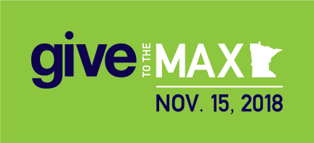
Please Click here to donate.
Please share this link with friends, family and groups you are a member of on Facebook and via email. Click for the Chapter 27 FB page or click vfpchapter27.org or VeteransforPeace.org (National) for more information about Veterans for Peace and Chapter 27 located in the Twin Cities of Minneapolis/St. Paul Minnesota.
THANK YOU!

